AI-Based Smart Wearable Device using the Arduino UNO Q

Bharath Kumar Medi
Department of Electrical and Computer Engineering
University of Alabama at Birmingham
Birmingham,USA
medibharathkumar@gmail.com

Abstract—Visual impairment significantly affects independent mobility and safe navigation in daily life . This project proposes an AI-Based Smart Wearable Device using the Arduino UNO Q that integrates the YOLO object detection algorithm for real-time environmental perception. To achieve high-accuracy classification of complex scenes, the system utilizes internet connectivity to delegate intensive computer vision tasks to cloud-based servers. Instead of verbal feedback, the device employs a multi-beep alert system that provides intuitive hazard warnings through frequency-modulated audio. The proposed solution aims to deliver a high-performance, internet-integrated assistive technology that enhances situational awareness and safety for visually impaired individuals.
Keywords— Arduino UNO Q, Computer Vision, Internet Connectivity, Multi-beep Alert System, YOLO

INTRODUCTION

Visual impairment is a major global health concern that affects an individual’s ability to navigate safely and independently. Loss of vision restricts awareness of obstacles, moving objects, and environmental changes, increasing the risk of accidents and dependency on others. According to the World Health Organization, more than 2.2 billion people worldwide suffer from some form of visual impairment [10]. While traditional aids such as white canes and guide dogs provide partial assistance, they are limited in the amount of contextual information they can convey [8].
Recent advancements in artificial intelligence (AI), embedded systems, and computer vision have significantly accelerated the development of intelligent assistive technologies capable of perceiving and interpreting real-world environments in real time [5], [6]. In particular, the YOLO (You Only Look Once) algorithm has emerged as a highly efficient object detection framework due to its ability to perform single-pass inference with high speed and accuracy [4]. This capability makes it well-suited for deployment in wearable systems where low latency and real-time responsiveness are critical. The integration of such advanced computer vision techniques with embedded platforms enables devices to not only detect objects but also classify and contextualize them within dynamic environments. As a result, these technologies are increasingly being adopted in assistive applications aimed at improving situational awareness for visually impaired individuals [2], [8].
This project proposes an AI-Based Smart Wearable Device that integrates object detection, distance sensing, and intuitive feedback mechanisms into a compact and portable system. The device combines YOLO-based visual perception with ultrasonic sensing to estimate the distance of surrounding objects, thereby providing both identification and spatial awareness [9]. The hardware foundation is built around the Arduino UNO Q, which manages real-time sensor data acquisition and system control [1]. Due to the limited memory and processing capabilities of embedded microcontrollers, the system leverages an external processing environment to execute computationally intensive tasks such as deep learning inference [3], [5]. This hybrid design ensures that the system maintains real-time performance while still benefiting from advanced AI capabilities.

PROPOSED METHODOLOGY

A. Arduino App Lab Integration

The control unit interfaces directly with the Arduino App Lab to create a seamless hardware-software bridge between the physical wearable components and a digital processing environment. While the Arduino UNO Q manages real-time sensor data from the ultrasonic unit locally, the App Lab environment provides the necessary computational overhead to execute the YOLO detection model and host the system’s Web UI [1], [4]. This architecture enables efficient coordination between embedded sensing and high-level processing, which is essential for real-time assistive applications. The integration of embedded platforms with AI-based processing environments has been widely recognized as an effective approach for handling computationally intensive tasks in resource-constrained systems [5].

This integration functions as a hybrid processing ecosystem where the Arduino handles low-latency hardware interrupts—such as distance pulsing—while the App Lab manages the data-intensive computer vision pipeline. The Web UI hosted within the App Lab allows for real-time system monitoring, enabling users or developers to adjust safety thresholds T and monitor detection probability P dynamically. By offloading the visual analysis to this integrated environment, the device achieves high-accuracy object recognition without overtaxing the microcontroller's local memory [3][5]. Furthermore, this setup facilitates a non-verbal multi-beep alert system by returning processed classification data to the hardware for immediate audio triggering [6][8].

B. YOLO-Driven Computer Vision

The proposed system employs a lightweight object detection model based on the YOLO (You Only Look Once) architecture to achieve real-time object localization and classification [4]. YOLO is a single-shot detection algorithm that processes the entire image in one forward pass, enabling the identification of multiple objects such as pedestrians, vehicles, and everyday items with minimal latency [4]. In this work, a resource-efficient variant of the model is utilized to ensure compatibility with embedded hardware constraints. By performing inference primarily on device, the system achieves low latency and reduced reliance on network connectivity, which is essential for assistive navigation in dynamic environments [5][6].

C. Multi-Beep Alert Logic
The system translates real-time detection results from the YOLO model into a non-verbal multi-beep alert system [4][6]. To ensure clear environmental communication, the audio feedback utilizes a proximity-based frequency modulation combined with unique identifiers for detected objects [6][8].

- Label-Specific Identifiers: Each object detected by the YOLO model is assigned a distinct audio signature or beep tone [4]. For example, a "person" label may trigger a different base pitch than a "vehicle" label, allowing the user to distinguish between different environmental elements through sound alone [6][8].

Safe Range: When detected labels are outside the immediate navigation path, the system remains idle or produces long-interval, low-frequency beeps to maintain situational awareness without causing fatigue [8].

Caution Range: As an object moves into the secondary safety zone, the specific beep pattern for that label accelerates in tempo, signalling an approaching obstacle [6].

Critical Threshold: Once an object crosses the primary safety threshold T, the system generates rapid, high-frequency multi-beeps. This urgent audio feedback indicates an immediate hazard, requiring the user to take corrective action [6].

This multi-modal approach ensures that the Arduino UNO Q provides semantic understanding of the surroundings while the multi-beep alert system minimizes the cognitive load typically associated with verbal instructions [1][6][8].
D. Mathematical Logic
- Let:
- $I(x,y)$= Input image
- $M$= Detection model
- $C$= Classification output
- $D$= Distance from ultrasonic sensor
- $T$= Threshold distance
- $B(t)$= Beep alert signal
- $C=M(I)$
$$\text{If }C=1\text{ and }D≤T→B(t)=1 \\ \text{Else }B(t)=0$$
This logic ensures alerts are generated only when necessary, reducing unnecessary alerts and improving system efficiency [5][6].

- MAIN BODY SECTION
The proposed system operates on a multi-sensor, cloud-assisted AI perception framework that enables real-time environmental understanding for assistive navigation [5][6]. A camera mounted on the wearable device continuously captures video frames from the user’s surroundings. These frames are transmitted to the Arduino App Lab environment through a persistent internet connection, where a deep learning–based object detection model performs real-time analysis [4][5]. The model identifies and localizes multiple objects such as pedestrians, vehicles, doors, furniture, and other potential obstacles. Each detected object is mapped to predefined semantic classes, allowing the system to interpret the environment at a higher level rather than merely detecting motion or shapes [6][8].
Simultaneously, an ultrasonic sensor operates in parallel as a complementary sensing module. It emits high-frequency sound waves and calculates the time taken for the reflected signal to return, thereby estimating the distance to nearby obstacles with high accuracy [9]. This sensing mechanism is independent of lighting conditions and visual clarity, ensuring reliable operation in low-light, dark, or visually cluttered environments where camera-based detection may be less effective [2].
The system performs sensor fusion by combining AI-based object recognition with real-time distance measurements. This integrated approach allows the system to assess both the type and proximity of obstacles, enabling more intelligent decision-making [2][8]. A predefined safety threshold distance is used to evaluate collision risk. When an object is detected within this threshold, the system activates a multi-beep alert mechanism [6].
The alert system is designed to provide intuitive, non-verbal feedback using a buzzer. Distinct beep patterns are assigned to different object categories, enabling the user to differentiate between obstacles without relying on speech output [6][8]. Additionally, the alert frequency dynamically adapts based on proximity: objects in a safe range produce slower and lower-frequency beeps, while objects approaching a critical distance trigger rapid, high-frequency beep sequences. This graded alert mechanism helps the user understand both the urgency and nature of the obstacle.
By combining cloud-based AI processing, ultrasonic distance sensing, and adaptive multi-beep alerts, the system achieves a robust, responsive, and user-friendly assistive navigation solution [5][6]. This architecture minimizes false detections, improves environmental awareness, and ensures reliable performance in diverse real-world conditions [2][8]. The overall system operation is illustrated in Figure 1, where inputs from the web camera and ultrasonic sensor are processed by the Arduino UNO Q. The system performs simultaneous object detection and distance measurement, and based on the detection result, it determines whether an alert is required. If no object is detected, the system continues monitoring, whereas if an object is identified, an appropriate beep alert is triggered based on the detected label
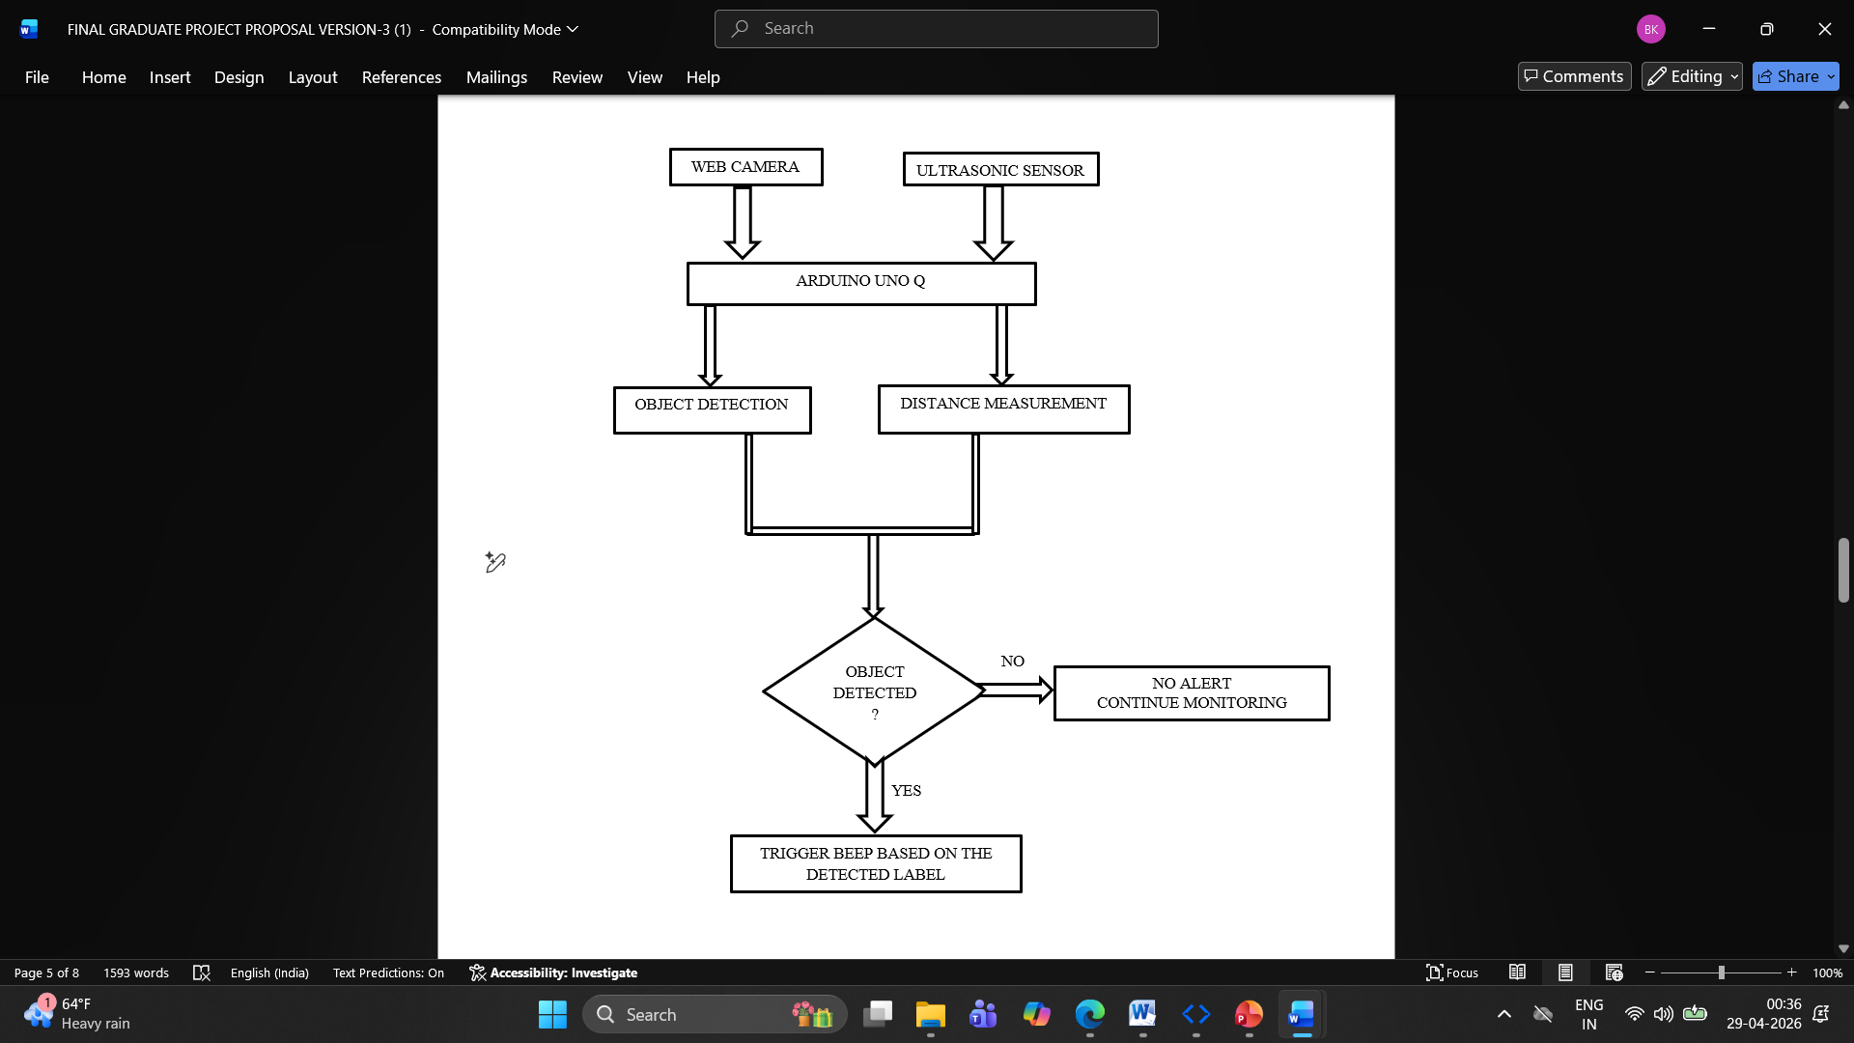
Figure.1. Process Flow Diagram.

- COMPONENTS DESCRIPTION
- Hardware Components
The proposed smart wearable device is built using a combination of sensing, processing, and alert components to achieve real-time assistive navigation [6].
- The Arduino UNO Q serves as the primary embedded platform, integrating both a microcontroller (MCU) and a Linux-based processing unit (MPU) [1]. It manages sensor interfacing, communication with Arduino App Lab, and control of the alert system.

- A Full HD webcam is used to capture real-time video frames of the user’s surroundings. It provides high-resolution image acquisition, which improves object detection accuracy. The webcam connects via USB and streams video data to the Arduino App Lab environment for AI-based processing [4][5].

- A 3V-compatible ultrasonic sensor is used for obstacle distance measurement [9]. The selection of a low-voltage sensor ensures safe and efficient power distribution within the system, as the 5V supply line is allocated to the buzzer and other peripherals. The sensor operates by measuring the time-of-flight of reflected sound waves, providing accurate real-time distance estimation. This design improves overall power management, reduces electrical interference, and enhances system stability while maintaining reliable performance independent of lighting conditions [2][9].

- A 5V piezoelectric buzzer is used to generate multi-beep alert patterns. Different beep sequences represent different object categories and proximity levels, enabling intuitive non-verbal feedback [6][8].

- A USB hub is used to expand connectivity by allowing multiple USB devices, such as the webcam and other peripherals, to be connected to the Arduino UNO Q simultaneously. It ensures stable data transfer and reliable peripheral integration.

- A 10000 mAh portable power bank supplies power to the entire system. It supports USB-based power delivery and ensures extended operation time, making the system suitable for continuous real-world usage.

- A protective helmet serves as the structural mounting platform for all system components. It ensures stable placement of the camera, ultrasonic sensor, Arduino UNO Q, and buzzer, while maintaining user comfort and proper alignment with the user’s field of view.

The hardware architecture of the proposed system is shown in Figure 2, where the Arduino UNO Q serves as the central processing unit interfacing with all components. The ultrasonic sensor provides real-time distance measurements, while the webcam captures visual data for object detection. Both the webcam and power supply are connected through a USB hub, ensuring stable operation and efficient power distribution. The processed output is communicated to a 5V buzzer, which generates alert signals to notify the user.

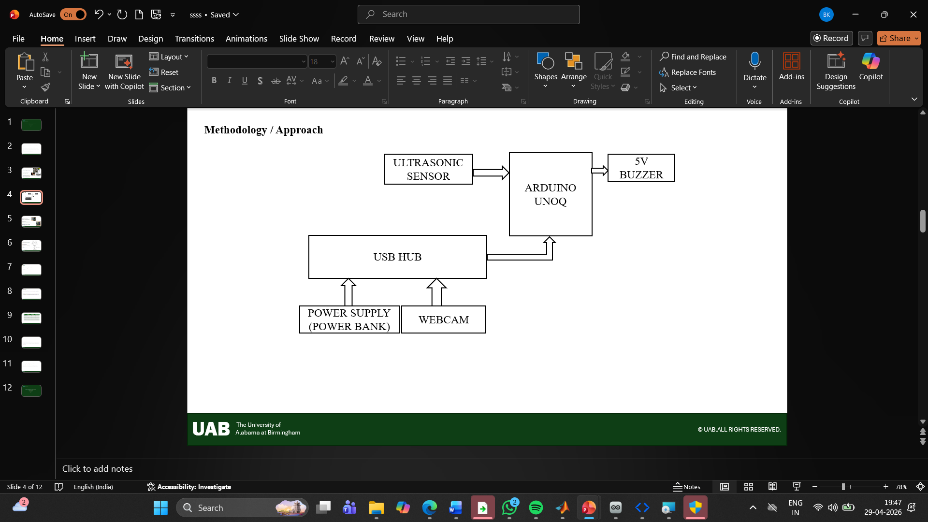

Figure.2. System Block Diagram
- Software Components
The software architecture of the proposed system is designed using a combination of cloud-based processing, embedded programming, and web technologies to enable real-time object detection, system control, and user monitoring [5][6].
- Arduino App Lab serves as the central cloud-based platform for real-time object detection and system coordination. It processes incoming video frames from the camera, executes the AI model, and manages communication between the detection pipeline and hardware components [4][5]. Continuous internet connectivity is required to maintain synchronization and ensure reliable operation.
- A pretrained deep learning–based object detection model is used to identify and classify objects such as persons, vehicles, and common obstacles [4]. The model processes video frames in real time and outputs bounding boxes and class labels, enabling semantic understanding of the environment [5].
- Python is used for implementing the AI pipeline within the Arduino App Lab environment. It handles tasks such as image processing, model inference, detection filtering, and interaction with the Web UI [5]. Python scripts also manage the logic for triggering alerts based on object detection results and system conditions [6].
- The microcontroller is programmed using an Arduino sketch written in C/C++. The sketch handles ultrasonic sensor operation, including triggering pulses and calculating distance using time-of-flight principles [9]. It also controls the buzzer to generate multi-beep alert patterns based on commands received from the processing unit [6].
- The Web UI is developed using HTML and CSS to provide a real-time visualization interface. It displays live video streams along with bounding boxes and labels of detected objects [5]. The interface also supports system monitoring, debugging, and safety observation, making it useful for both development and real-world usage.
- The Bridge API enables communication between the Linux-based processing unit and the microcontroller. It allows seamless data exchange for triggering buzzer alerts, reading ultrasonic sensor values, and executing hardware-level commands [1].
- DISCUSSION
The prototype is implemented as a wearable smart device system where all components are integrated into a compact and portable setup.
- The camera is mounted on the front of the helmet to capture the user’s field of view.
- The ultrasonic sensor is positioned to detect obstacles directly ahead.
- The Arduino UNO Q board is embedded within or attached on the top of the helmet for processing and control.
- The buzzer is placed near the user to provide clear and immediate alert signals.
- A USB hub connects the camera and other peripherals to the processing unit.
- The system is powered using a 10000 mAh power bank, ensuring extended operation and mobility.
The system operates by continuously capturing visual data, transmitting frames to Arduino App Lab for object detection, measuring obstacle distance using the ultrasonic sensor, and generating multi-beep alerts based on object type and proximity. The Web UI provides real-time visualization of system operation, including detected objects and bounding boxes.
The developed prototype of the proposed system is shown in Figure 3, where all hardware components are integrated into a wearable device structure. The Arduino UNO Q acts as the central controller, interfaced with the ultrasonic sensor for obstacle detection and a webcam for real-time object recognition. A USB hub is used to manage connectivity and power distribution, while the buzzer provides audio feedback to the user. The compact and lightweight design demonstrates the feasibility of implementing an assistive navigation system in a practical, real-world environment.
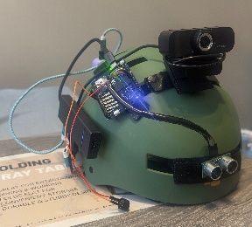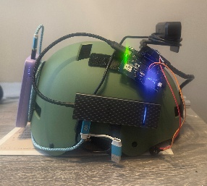
Figure.3. Prototype
- RESULTS
The proposed AI-Based Smart Wearable device system was successfully implemented and evaluated for real-time assistive navigation. The system demonstrated reliable performance in detecting multiple objects, including pedestrians, vehicles, and common indoor and outdoor obstacles such as chairs, bottles, cups, and cell phones. The integration of Arduino App Lab enabled effective cloud-assisted object detection, while the Web UI provided real-time visualization of detected objects through bounding boxes and labels. The system maintained consistent performance under typical operating conditions, confirming its suitability for practical use.
The ultrasonic sensor module provided accurate real-time distance measurements to nearby obstacles, enabling precise proximity detection. The use of a 3V-compatible ultrasonic sensor ensured stable operation and efficient power management within the system. The distance measurements were effectively combined with object detection results to assess potential hazards. This integration allowed the system to identify obstacles even when the AI model failed to recognize them, such as walls or visually indistinct objects, thereby improving overall system reliability.
The real-time performance of the proposed system is illustrated in Figure 4, where detected objects such as persons, chairs, and kites are identified along with their corresponding distance measurements.
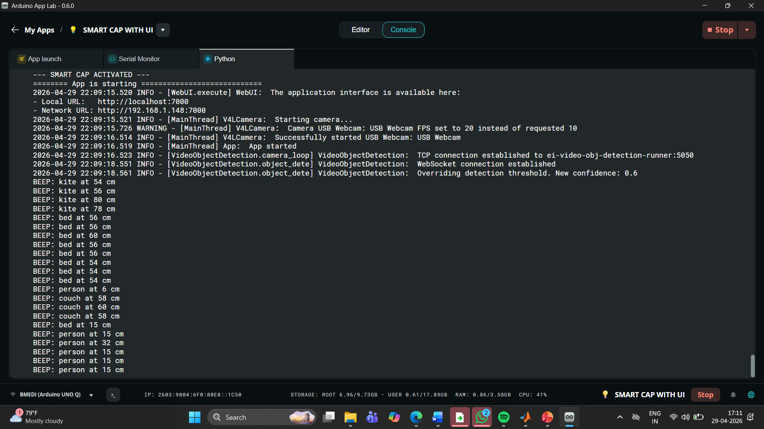
Figure.4. Console Output
The multi-beep alert system functioned as an effective non-verbal feedback mechanism for the user. Distinct beep patterns were successfully assigned to different object categories, allowing users to differentiate between objects without relying on speech-based guidance. Additionally, the system dynamically adjusted the beep frequency based on the proximity of detected objects, where closer obstacles triggered faster alert signals. This adaptive feedback mechanism enabled intuitive and immediate situational awareness, reducing response time and enhancing user safety.
The Web UI interface played a critical role in system monitoring and validation by displaying real-time detection outputs and system activity. It allowed continuous observation of detected objects, their positions, and corresponding labels, supporting both debugging and safety monitoring purposes. Overall, the system achieved low-latency performance, accurate detection, and reliable alert generation, demonstrating its effectiveness as a practical and affordable assistive navigation device for visually impaired individuals.
The real-time object detection results obtained through the Web UI are presented in Figure 5, where various objects such as a bed, bottle, person, and cell phone are accurately identified with confidence scores. The system utilizes a computer vision model to draw bounding boxes around detected objects and label them accordingly. These results demonstrate the capability of the system to recognize multiple object classes under different environmental conditions. The consistent detection performance highlights the effectiveness of the integrated vision-based processing module for assistive applications.
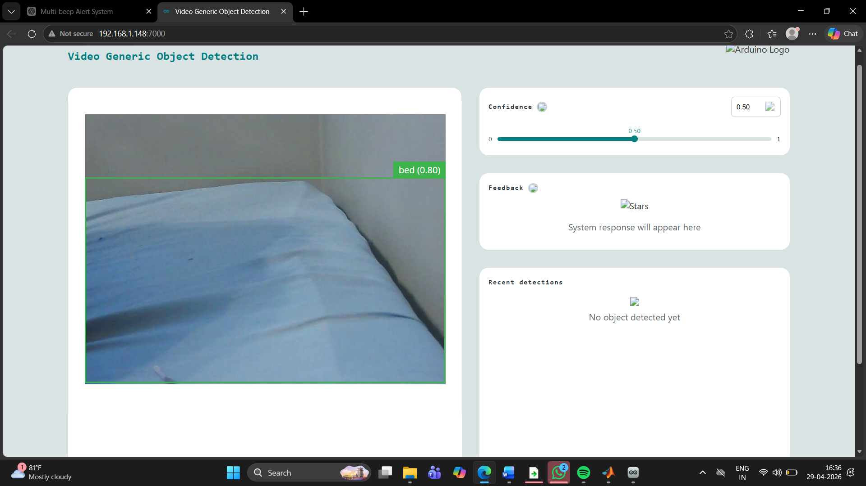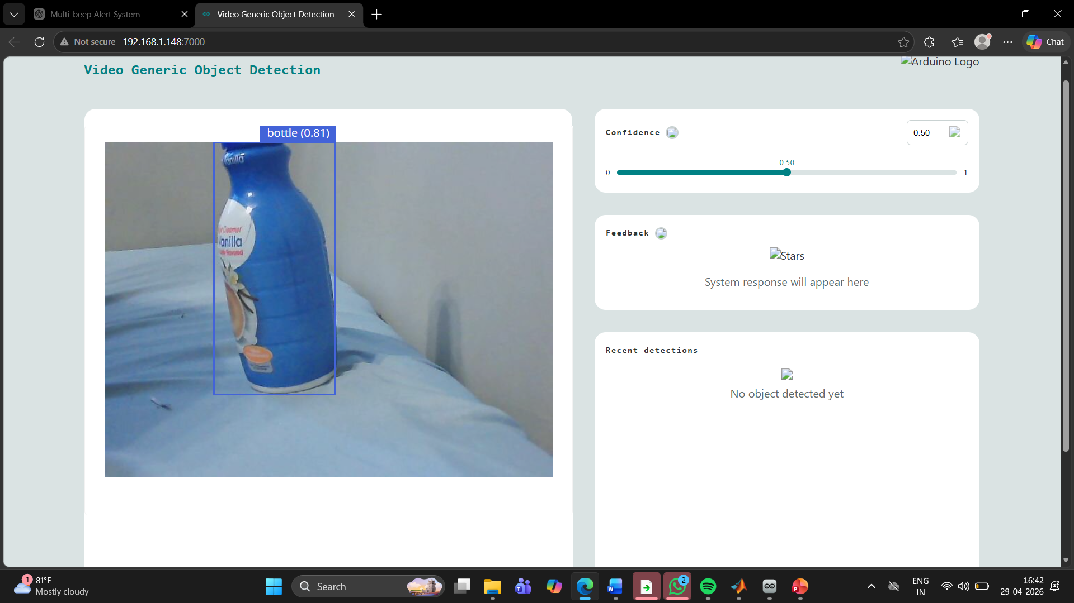
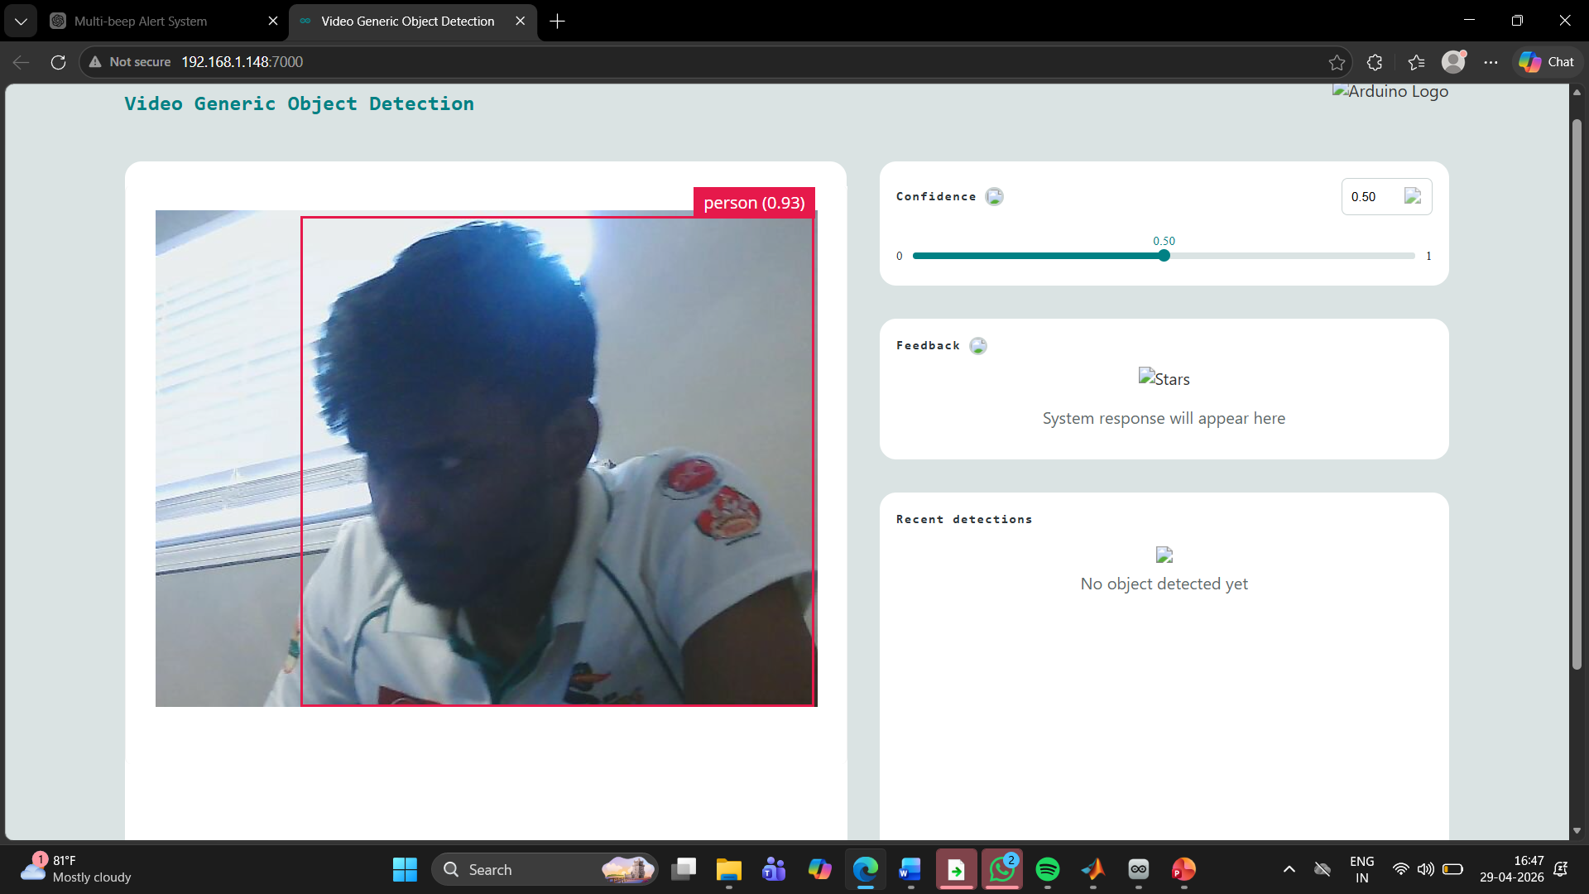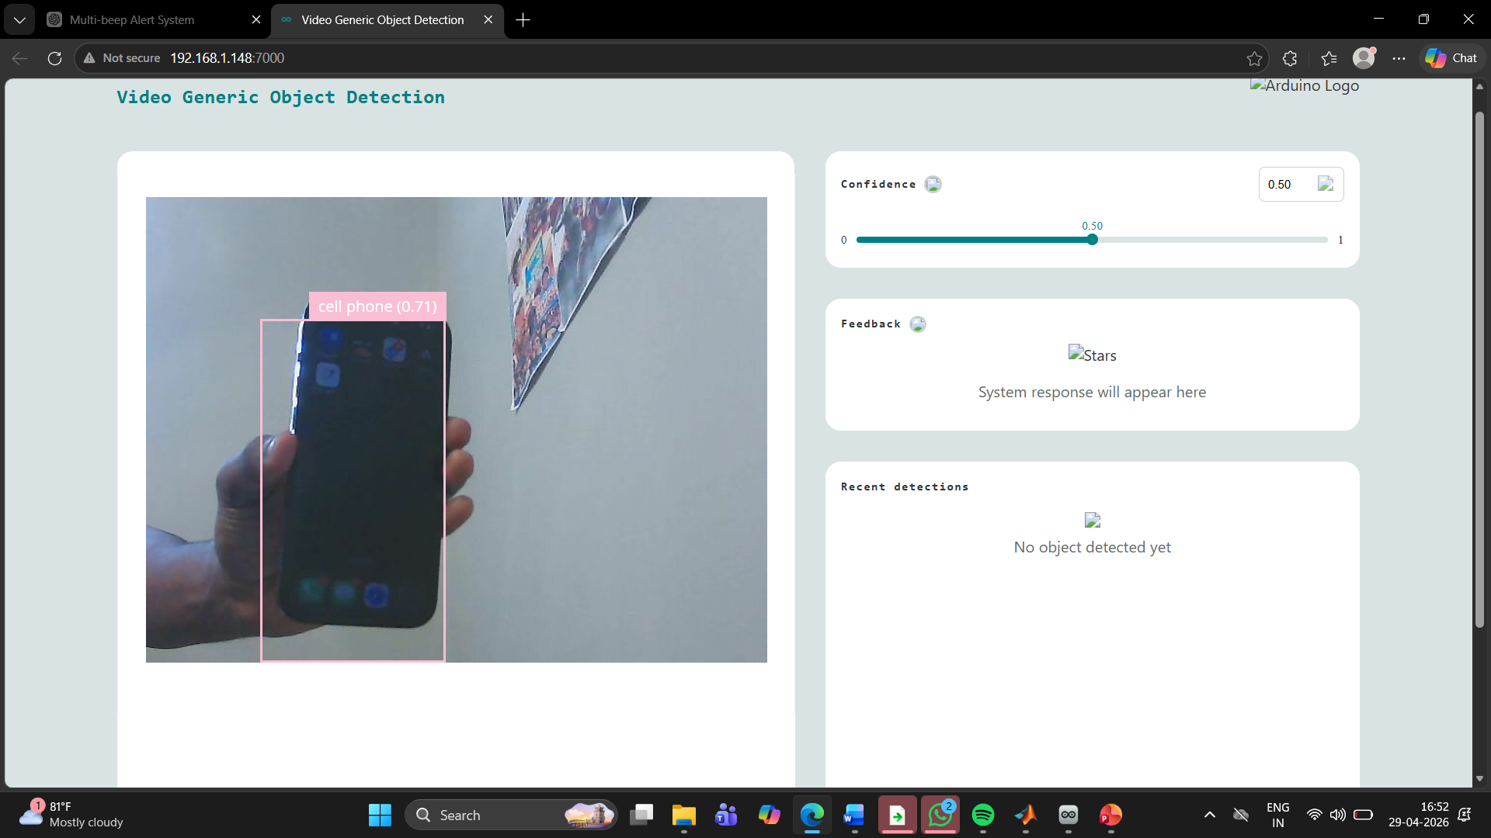
REFERENCES

[1] Arduino UNO Q Foundation, “Arduino UNO Q 4 Model B datasheet,” Cambridge, U.K., 2023. [Online]. Available: https://www.arduino.cc
[2] A. Aladrén, G. López-Nicolás, L. Puig, and J. Guerrero, “Navigation assistance for the visually impaired using RGB-D sensor with range expansion,” IEEE Syst. J., vol. 10, no. 3, pp. 922–932, Sep. 2016.
[3] A. G. Howard et al., “MobileNets: Efficient convolutional neural networks for mobile vision applications,” arXiv:1704.04861, 2017.
[4] J. Redmon and A. Farhadi, “YOLOv3: An incremental improvement,” arXiv:1804.02767, 2018.
[5] L. Wang, Z. Li, and Y. Wang, “Real-time object detection on embedded systems using deep learning,” IEEE Trans. Ind. Informat., vol. 15, no. 1, pp. 388–397, Jan. 2019.
[6] M. A. Rahman, M. M. Islam, and M. R. Hossain, “An AI-based wearable assistive system for visually impaired people,” IEEE Access, vol. 8, pp. 209184–209194, 2020.
[7] OrCan m Technologies Ltd., “OrCam MyEye—Assistive technology for the visually impaired,” Jerusalem, Israel, 2024. [Online]. Available: https://www.orcam.com
[8] R. Tapu, B. Mocanu, and T. Zaharia, “Wearable assistive devices for visually impaired: A state-of-the-art survey,” Pattern Recognit. Lett., vol. 137, pp. 37–52, 2020.
[9] S. Gupta, R. Singh, and P. Kumar, “Smart navigation system for visually impaired using ultrasonic sensor and Arduino UNO Q,” Int. J. Eng. Res. Technol. (IJERT), vol. 9, no. 6, pp. 421–425, Jun. 2020.
[10] World Health Organization, “Blindness and vision impairment,” WHO, Geneva, Switzerland, 2023. [Online]. Available: https://www.who.int/news-room/fact-sheets/detail/blindness-and-visual-impairment

Figure.5. Web UI Results

